**Chapter 2**

**Descriptive Statistics**

**Case Problem: Heavenly Chocolates Website Traffic**

1. Descriptive statistics for the time spent on the website, number of pages viewed, and amount spent are shown below. **(2pts)**

|  |  |  |  |
| --- | --- | --- | --- |
|  | **Time (min)** | **Pages Viewed** | **Amount Spent ($)** |
| Mean | 12.8 | 4.8 | 68.13 |
| Median | 11.4 | 4.5 | 62.15 |
| Standard Deviation | 6.06 | 2.04 | 32.34 |
| Range | 28.6 | 8 | 140.67 |
| Minimum | 4.3 | 2 | 17.84 |
| Maximum | 32.9 | 10 | 158.51 |
| Sum | 640.5 | 241 | 3406.41 |

The mean time a shopper is on the Heavenly Chocolates website is 12.8 minutes, with a minimum time of 4.3 minutes and a maximum time of 32.9 minutes. The following histogram demonstrates that the data are skewed to the right.



The mean number of pages viewed during a visit is 4.8 pages with a minimun of 2 pages and a maximum of 10 pages A histogram of the number of pages viewed indicates that the data are slightly skewed to the right.



The mean amount spent for an on-line shopper is $68.13 with a minimum amount spent of $17.84 and a maximum amount spent of $158.51. The following histogram indicates that the data are skewed to the right.



2. Summary by Day of Week **(2pts)**

|  |  |  |  |  |
| --- | --- | --- | --- | --- |
|  | **Day of Week** | **Frequency** | **Total Amount Spent ($)** | **Average Amount Spent ($)** |
|  | Sunday | 5 | 218.15 | 43.63 |
|  | Monday | 9 | 813.38 | 90.38 |
|  | Tuesday | 7 | 414.86 | 59.27 |
|  | Wednesday | 6 | 341.82 | 56.97 |
|  | Thursday | 5 | 294.03 | 58.81 |
|  | Friday | 11 | 945.43 | 85.95 |
|  | Saturday | 7 | 378.74 | 54.11 |
|  | Total | 50 | 3406.41 | 68.13 |

The above summary shows that Monday and Friday are the best days in terms of both the total amount spent and the averge amount spent per transaction. Friday had the most purchases (11) and the highest value for total amount spent ($945.43). Monday, with nine transactions, had the highest average amount spent per transaction ($90.38). Sunday was the worst sales day of the week in terms of number of transactions (5), total amount spent ($218.15), and average amount spent per transaction ($43.63). However, the sample size for each day of the week are very small, with only Friday having more than ten transactions. We would suggest a larger sample size be taken before recommending any specific stratgegy based on the day of week statistics.

3. Summary by Type of Browser **(2pts)**

|  |  |  |  |  |
| --- | --- | --- | --- | --- |
|  | **Browser** | **Frequency** | **Total Amount Spent ($)** | **Average Amount Spent ($)** |
|  | Firefox | 16 | 1228.21 | 76.76 |
|  | Internet Explorer | 27 | 1656.81 | 61.36 |
|  | Other | 7 | 521.39 | 74.48 |

Internet Explorer was used by 27 of the 50 shoppers (54%). But, the average amount spent spent by customers who used Internet Explorer ($61.36) is less than the average amount spent by customers who used Firefox ($76.76) or some other type of browser ($74.48). This result would suggest targeting special promotion offers to Firefox users or users of other types of browsers. But, before recommending any specific strategies based upon the type of browser, we would suggest taking a larger smaple size.

4. A scatter diagram showing the relationship between time spent on the website and the amount spent follows: **(1.5pts)**

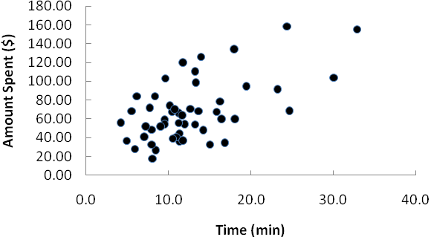

The sample correlation coefficient between these two variables is .580. The scatter diagram and the sample correlation coefficient indicate a postive relationship between time spent on the website and the total amount spent. Thus, the sample data support the conclusion that customers who spend more time on the website spend more.

5. A scatter diagram showing the relationship between the number of pages viewed and the amount spent follows: **(1.5pts)**

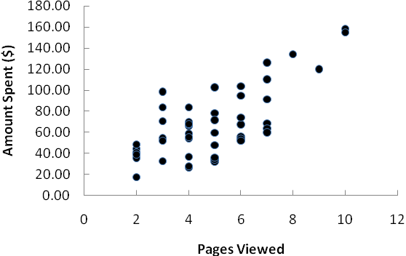

The sample correlation coefficient between these two variables is .724. The scatter diagram and the sample correlation coefficient indicate a postive relationship between time spent on the website and the number of pages viewed. Thus, the sample data support the conclusion that customers who view more website pages spend more.

6. A scatter diagram showing the relationship between the number of pages viewed and the time spent on the website follows: **(1pts)**

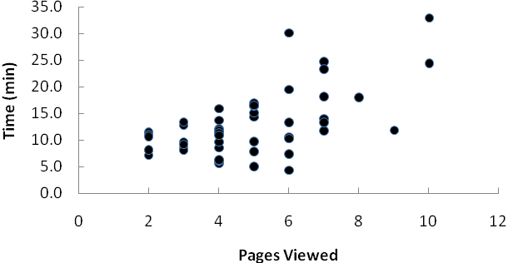

The sample correlation coefficient between these two variables is .596. The scatter diagram and the sample correlation coefficient indicate a postive relationship between the number of pages viewed and the time spent on the website.

**Summary**: The analysis indicates that on-line shoppers who spend more time on the company’s website and/or view more website pages spend more money during their visit to the website. If Heavenly Chocolates can develop an attractive website such that on-line shoppers are willing to spend more time on the website and/or view more pages, there is a good possiblity that the company will experience greater sales. And, consideration should also be given to developing marketing strategies based upon possible differences in sales associated with the day of the week as well as differences in sales associated with the type of browser used by the customer.